Q1. Which of the following decimal numbers would have an infinite number of bits when expressed in binary?
A. 0.05 B. 0.125 C. 0.375 D. 0.5
Q2. Which of the following is a correct description of memory interleaving?
A. When new data is stored in cache memory, writing data in the cache that is no longer needed back to main memory.
B. Compensating for the gap in access time between main memory and a magnetic disk.
C. Updating main memory and cache memory simultaneously.
D. Dividing main memory into several partitions that can be accessed in parallel in order to perform consecutive memory accesses efficiently.
Q3. Which of the following execution control methods permits processing of multiple instructions in parallel by dividing the instruction execution cycle into several stages (instruction fetch, instruction decoding, operand address decoding, operand fetch, and execution) and then assigning separate devices to each stage of processing?
A. Data flow B. Pipeline
C. Process D. Microprogram
Q4. Which of the following media has the largest storage capacity per disk?
A. CD-R B. DVD-RAM C. FD D. MO
Q4. There is one virtual memory system that divides the virtual address space into areas of a fixed length. Which of the following terms is the word for this fixed-length area?
A. Sector B. Segment C. Frame D. Page
Q5. What is the purpose of task management in an OS?
A. Providing a command-based interactive interface for the operator.
B. Efficient implementation of virtual storage.
C. Performing control functions in order to use the processor more efficiently.
D. To permit the processing of data without needing to be aware of the hardware.
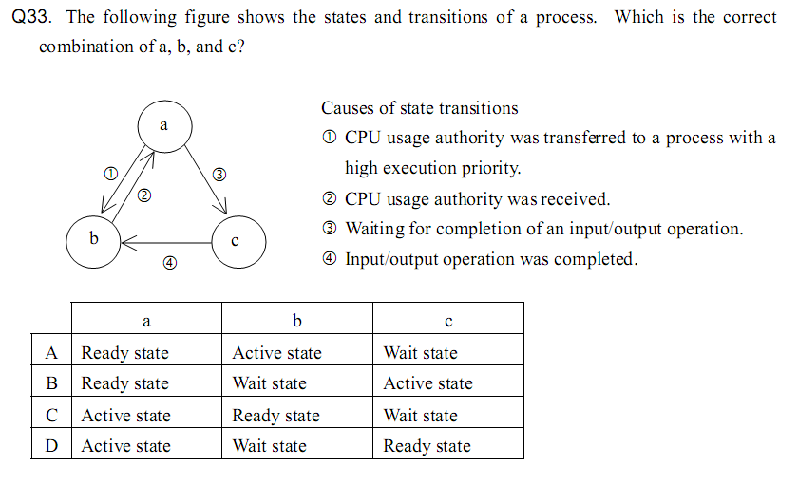
Q6. Which of the following is applicable to “dynamic link library (DLL)”?
A. It is compiled by the compiler.
B. It is created by the pre-compiler before compiling.
C. It is linked by the OS before execution.
D. It is linked and compiled by the linker when the load module is created.
Q7. Which of the following is applicable to indexed file organization, a type of file organization method?
A. It permits direct access of records according to the address of each record. Mediums need have an index area
B. It keeps track of records in the order in which they were written. Only permits sequential access.
C. It consists of data areas, called "members," and a registration area for managing member information. This method is suitable for program storage.
D. It consists of an area where records are written, and an area where record key information is written.
Q8. Which of the following most accurately describes a system bus?
a) Widely used in PCs, this standard is for serial transfer of data with a modem or peripheral device.
b) It is a digital signal transfer path shared by multiple devices within the computer.
c) It is a device for converting digital signals to analog signals and analog signals to digital signals.
d) It is a mechanism for transferring data between I/O devices and main memory independently from the CPU.
Q9. What is the correct order of processing and modes for the virtual storage of a paging system when accessing a page that is not in real storage? Assume that there is no page currently available in real storage.
a) Determine the replacement page → page out → page fault → page in
b) Determine the replacement page → page in → page fault → page out
c) Page fault → determine the replacement page → page out → page in
d) Page fault → determine the replacement page → page in → page out
Q10. Which of the following is a system for loading the necessary segments at run time by dividing the load module into several segments to be executed exclusively?
a) Overlay b) Swapping
c) Dynamic relocation d) Dynamic linking
Q11. In the case of a client-server system, which process is most appropriately performed by the server?
a) Print previews
b) Database updates
c) Checking the format of input data
d) Displaying pull-down menus
Q12. In which system does one computer function normally while the other is in the wait status?
a) Dual system
b) Duplex system
c) Multi-processing system
d) Load share system
Q13. Which of the following types of memory allows data to be rewritten and erased electrically, and retains its contents even when the power is turned off?
a) DRAM b) SRAM
c) Flash memory d) Mask ROM
Q14. What is the average instruction execution time of a 50 MIPS processor?
a) 20 nanoseconds b) 50 nanoseconds
c) 2 microseconds d) 5 microseconds
Q15. Which of the following descriptions of RAID 0 is correct?
a) A RAID 0 array consists of multiple expensive but highly reliable disks, and is intended primarily for having a large storage capacity.
b) The purpose of a RAID 0 array is to improve transfer rate by subdividing data and performing cyclically parallel I/O on multiple magnetic disks.
c) A RAID 0 array performs CRC error correction on each block without requiring redundant magnetic disks.
d) A RAID 0 array consists of multiple inexpensive magnetic disks under the control of the OS in order to provide reliability and higher performance.
Q16. A processor consists of an arithmetic and logic unit and a control unit. Which of the following elements is part of the control unit?
a) Accumulator b) Adder
c) Complement register d) Instruction decoder
Q17. Which of the following descriptions of the LRU method in regards to page replacement algorithms is correct?
a) A method that replaces the oldest page
b) A method that replaces the page that was referenced last
c) A method that replaces the page whose elapsed time after last reference is the longest
d) A method that replaces the page that has been referenced least frequently
Q18. Which of the following functions of an OS assigns the right to use the CPU to the process that should be executed next from among all of the processes that are ready to be executed?
a) Allocator b) Initiator
c) Terminator d) Dispatcher
Q19. Assume that there is a multiprocessor system consisting of four processors, A through D. When comparing the two operation conditions ① and ② below, approximately how many times is the availability under condition ① as high as the availability under condition②? Assume that the availability ratio of each of the processors is 0.9, and that the availability ratio of system components other than the processors is 1.0.
[Operation Conditions]
① At least one processor (or more) needs to operate normally.
② All the processors must operate normally.

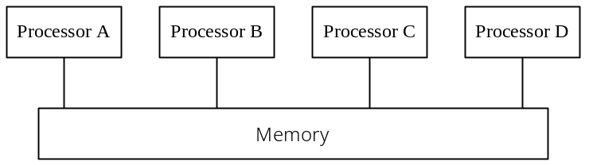

a) 0.5 b) 1.5 c) 3.0 d) 4.0

